**DAILY ONLINE ACTIVITIES SUMMARY**

|  |  |  |  |  |  |  |  |
| --- | --- | --- | --- | --- | --- | --- | --- |
| **Date:** | 23/06/2020 | | | | **Name:** | CHETHAN CK | |
| **Sem & Sec** | 4th SEM ‘A’ SEC | | | | **USN:** | 4AL18CS017 | |
| **Online Test Summary** | | | | | | | |
| **Subject** | | N/A | | | | | |
| **Max. Marks** | | N/A | | **Score** | | N/A | |
| **Certification Course Summary** | | | | | | | |
| **Course** | Facial recognition using python | | | | | | |
| **Certificate Provider** | | | Udemy | **Duration** | | | 3 Hours |
| **Coding Challenges** | | | | | | | |
| **Problem Statement:** 1. Write a Python Program to Split the array and add the first part to the end.  2. Write a C Program to Sort a stack using a temporary stack. | | | | | | | |
| **Status:** Completed | | | | | | | |
| **Uploaded the report in Github** | | | | YES | | | |
| **If yes Repository name** | | | | https://github.com/alvas-education-foundation/chethan_c_k | | | |
| **Uploaded the report in slack** | | | | YES | | | |

**Online Test Details:** N/A

**Certification Course Details:**

**Name of the course**: Facial recognition using python

**Certificate Provider**: Udemy

Today I had learned about real-time face makeup.

**Snapshot:**

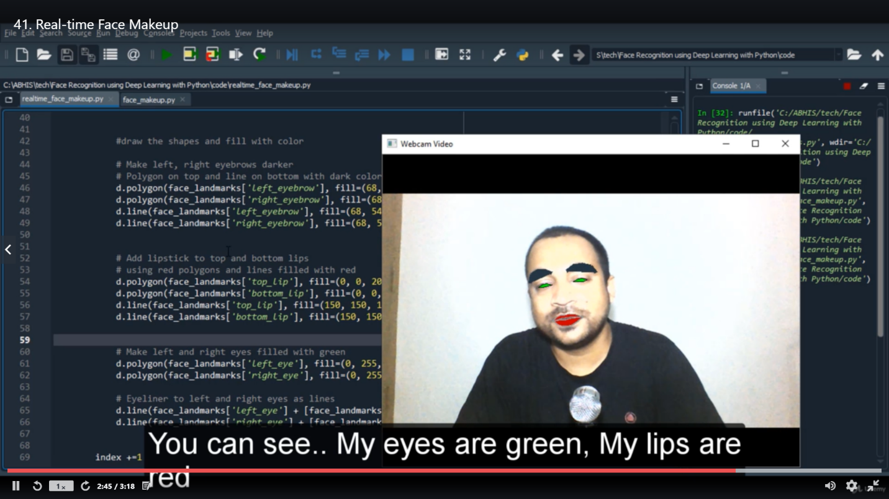

**Online Coding Details:**

Problem 1: Write a Python Program to Split the array and add the first part to the end.

**Snapshot:**

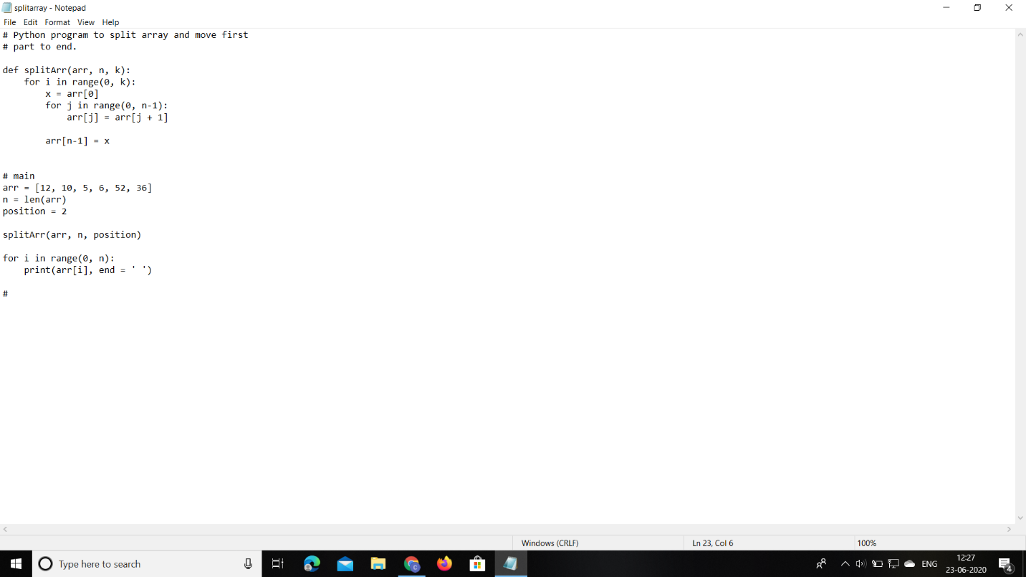

Problem 2: Write a C Program to Sort a stack using a temporary stack.

**Snapshot:**

